Smart home in a Box: Pilot Program

Pilot study of smart home in a box for the initial study of data collection on 500 homes across US

Version 1.0.0.3

Author: Vikramaditya Jakkula

Problem:

The smart home in a box project goal takes smart home solution to the every home. The place you live is more than a place to “hang your coat,” more than few walls and a roof. It is an investment, an expense, a retreat, a responsibility, an expression of yourself, and more. The home today has substantial investment in terms of cost and people are making the effort to go little beyond the basic needs to improve comfort level, which by itself is a clear sign for an economical smart home solution for a mass target market. The homeowner segment is the primary target sector for the smart home in a box solution.

Solution Offering/Product Details

The solution offered initial phase includes a pilot study of 500 homes being transformed into smart homes for data collection study.

Solution A: The solution A takes a wired approach.

|  |  |  |  |
| --- | --- | --- | --- |
| Sensor | Usage | Cost | Manufacturer |
| Motion Sensor + Custom Board | 12-24 (Location size) | 15$ + $4(board Cost) | Vision-Tek + Add-in Board (In-house) |
| Temperature | “” | 4$ + (Same board above) | In-House |
| Door Sensor | Location/Doors/Cabinets | 4$ | In-House |
| Power Meter | 1 | $200 | Energy Inc |
| Wiring | Location | 10 Cents per foot | Local store |
| USB Bus Helper | 1 per location | $20 per piece | Drill semi-conductor |
| Sheeva Plug | 1 per location | $100 per piece | Global Scale Technologies |
| Touch Screen | 1 per location | $300 per PC | Asus PC – EETOP |

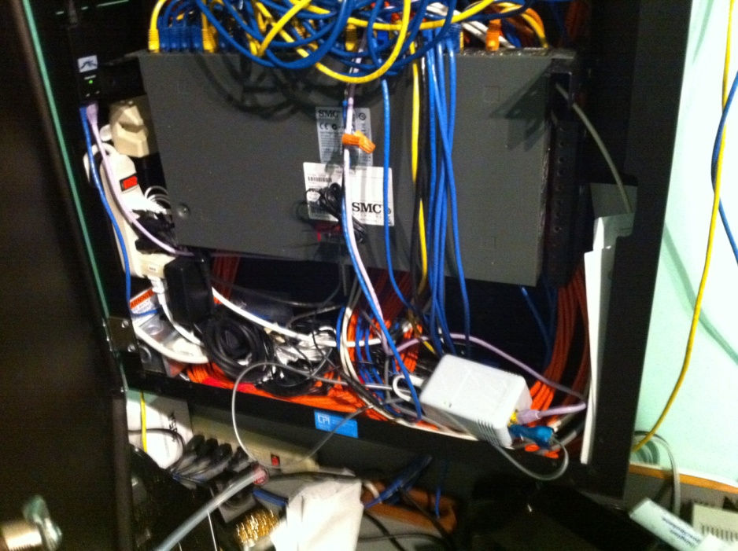

Figure . Sheeva Plug with data cables

Solution B: The solution B explores a wireless solution.

|  |  |  |  |
| --- | --- | --- | --- |
| Sensor | Usage | Cost | Manufacturer |
| Wireless Base Station | 1-2 location | Market Price: $600  Our Cost: $300 | Control 4 |
| Motion Sensor | Based on Location | Market Price: $150  Our Cost: $75 | Control 4 |
| Battery | Based on sensor |  |  |
| Motion Door Sensor | Door/Cabinet | MC: $150  Our Cost:: $75 | Control 4 |
| Lightening Sensor | Location | MC:$130  Our Cost: $60 | Control 4 |
| Touch Screen | 1 per location | $300 per PC | Asus PC – EETOP |
| Power Meter | 1 | $200 | Energy Inc |

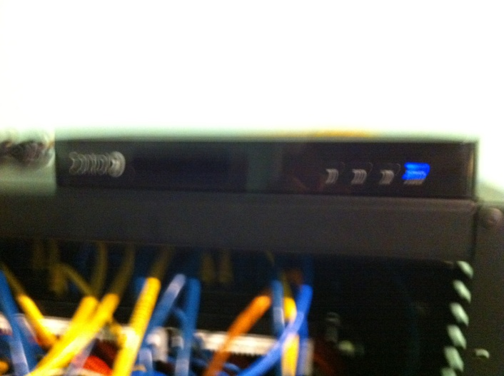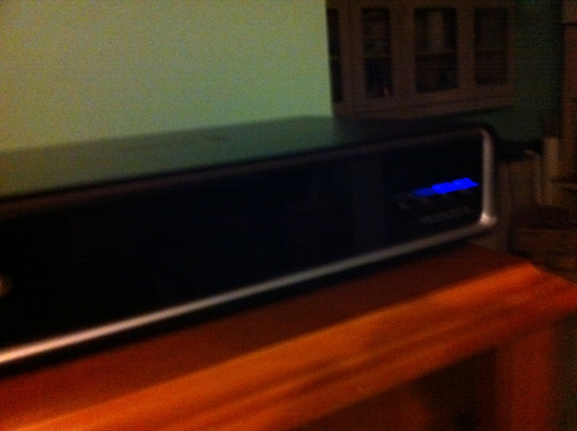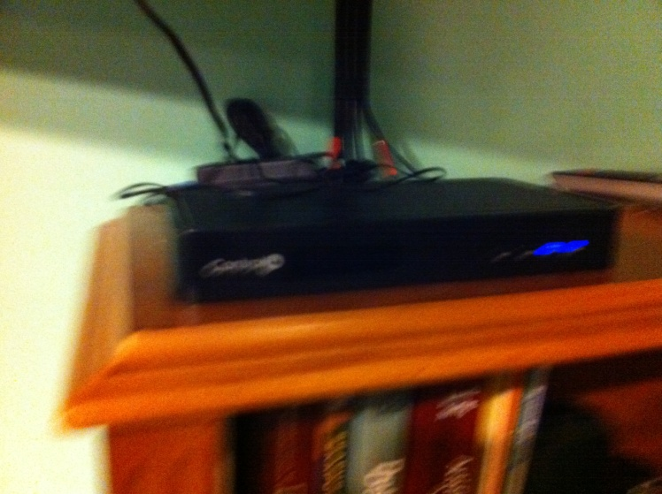

Figure 2. Control 4 wireless sensors

Trade-off:

|  |  |
| --- | --- |
| Solution A | Solution B |
| High Labor cost  High maintenance  Low/economic overall cost  Low devices cost for replacements | Low labor cost  Low mainataince as wireless  High Overall Cost  High device cost for replacement |

Subjects/ Consumers

The subject selection criterion is very critical. This helps improve the overall quality of study.

Minimum criteria to consider:

* Subjects should be of typical household age group to elderly population
* Multiple resident data is preferred, but also single resident data is allowed
* Minimum of 1 subject from different state in US to help us with geographical study of environment, lifestyle, and adaptability of the solution.
* Subject pool should include from kids to facilities with house pets along with other motion related entities like roomba (automatic cleaners), etc.
* Selecting all kind of subjects tech savvy, less tech savvy and no technology savvy personal as part of the study.

What to prove to Subject:

* The program is unique and beneficial by helping them evaluate and transform their home into a smart home.
* The program protects user privacy and has high trustworthiness and maintains regular standards & protocols.

The subjects participating ask one question what makes them happy?

* The pilot program should include an incentive program. The incentive should be awarded at the end of the program when data is collected successfully.
* 500$ Incentive after each year of successful data collection
* Users can keep sensor kits if data is collected for a longer period than 3 years.

What about less tech savvy subjects?

* The solution as part of the pilot study should include a manual as well as tech support line for the subjects to reach us for instructions during the setup phase and for any additional mainataince questions over the study duration.

Market Analysis

The market analysis is broken down into barrier analysis and feature analysis.

[A] Market Barrier Analysis

|  |  |
| --- | --- |
| Relative Merits/Barriers/Decision Criteria | Score |
|  |  |
| Available Resources | 4 |
| Market Conditions | 3 |
| Cost to Implement | 3 |
| Government/Regulatory Issues | 2 |
| Environmental Issues | 3 |
| Economic Factors | 3 |
| Technical Hurdles/Opportunities | 3 |
| Competitive Issues/Threats | 2 |
| Social/Political/Demographic Issues | 2 |
| Adaptability | 3 |
| Reliability/Trustworthiness | 2 |
|  |  |
|  |  |
| Note: Score is Low to High (1-5). The higher the score the better. The lower score means we need to work on them or are potential challenges |  |

[B] Feature Analysis:

* Product 1: Smart home in a box @ CASAS solution
* Product 2: Microsoft Research Smart Home
* Product 3: Home Automation Solution
* Market 1: Home owners.
* Market 2: Commercial or Work spaces.
* Market 3: Elderly assisted living.

|  |  |  |  |
| --- | --- | --- | --- |
| Feature | Product 1 | Product 2 | Product 3 |
|  |  |  |  |
| Performance | 3 | 4 | 2 |
| Energy Efficiency | 3 | 4 | 3 |
| Ease of Use | 3 | 3 | 3 |
| Convenience | 3 | 4 | 2 |
| Restocking Sensor Cost | 3 | 3 | 1 |
| Expansion Cost | 2 | 4 | 2 |
| Sanitation | 3 | 4 | 2 |
| Eco-friendly | 3 | 3 | 2 |
| Product Healthiness | 3 | 3 | 2 |
| Maintenance | 3 | 2 | 4 |
| Security | 3 | 3 | 3 |
| Home Automation | 4 | 4 | 4 |
| Pet Care | 2 | 3 | 0 |
| Audio/Video | 3 | 3 | 3 |
| Wired/Wireless | 3 | 4 | 3 |
| Household Management | 3 | 4 | 1 |
| HealthCare | 3 | 4 | 0 |
| Privacy | 3 | 3 | 0 |
| User friendly Software/UI | 3 | 5 | 0 |
| Appliance Friendly | 3 | 3 | 0 |
| Ease of Installation | 3 | 3 | 1 |
| Convenience | 3 | 4 | 2 |
| Training | 3 | 3 | 0 |
| Availability/Varity of Sensors/Technology | 3 | 3 | 0 |
| Life cycle cost(= Installed cost + mainataince cost ) (show it depreciates over time) | 3 | 4 | 0 |
| Proprietary/Open architecture | 4 | 2 | 0 |
| Tech Support | 3 | 3 | 0 |
|  |  |  |  |
|  |  |  |  |
| Feature | Market A | Market B | Market C |
| Performance | 3 | 2 | 5 |
| Energy Efficiency | 5 | 5 | 5 |
| Ease of Use | 3 | 2 | 5 |
| Convenience | 3 | 3 | 5 |
| Restocking Sensor Cost | 3 | 4 | 3 |
| Expansion Cost | 3 | 4 | 3 |
| Sanitation | 3 | 3 | 5 |
| Eco-friendly | 3 | 3 | 3 |
| Product Healthiness | 3 | 3 | 3 |
| Maintenance | 3 | 2 | 5 |
| Security | 3 | 3 | 5 |
| Home Automation | 3 | 3 | 5 |
| Pet Care | 3 | 1 | 1 |
| Audio/Video | 3 | 3 | 3 |
| Wired/Wireless | 3 | 3 | 3 |
| Household Management | 3 | 2 | 4 |
| HealthCare | 3 | 2 | 5 |
| Privacy | 3 | 3 | 3 |
| User friendly Software/UI | 3 | 2 | 4 |
| Appliance Friendly | 3 | 2 | 4 |
| Ease of Installation | 3 | 2 | 3 |
| Convenience | 4 | 3 | 4 |
| Training | 3 | 3 | 4 |
| Availability/Varity of Sensors/Technology | 3 | 3 | 3 |
| Life cycle cost(= Installed cost + mainataince cost ) (show it depreciates over time) | 3 | 3 | 3 |
| Proprietary/Open architecture | 3 | 3 | 3 |
| Tech Support | 3 | 3 | 3 |
|  |  |  |  |
|  | Market A | Market B | Market C |
| Product 1 | 1.86 | 1.33 | 2.36 |
| Product 2 | 2.33 | 2.06 | 2.52 |
| Product 3 | 1.03 | 0.9 | 1.11 |

Our current solution looks very feasible for Elderly or Assisted living setting. Also note that the scoring was done based on the document author and no survey was conducted.

People/Demographics

Roles & Man power requirements:

* PhD Student – 2 (Help in assembling kits and creating basic data collection system)

Role:

* + Build Kits and assemble them and test them supervised by System Administrator;
  + Create data storage system supervised by the System Administrator;
  + Temp role for 6 months; Hire on need basis during the rest of the phase for maintenance and resupply;
  + Assist Marketing Manager on need to need basis;
  + Report to system administrator
* Software Developer – 1 ( Interactive Interface creation)

Role:

* + Build compact user interface for smart home in box prototype solution.
  + Build a database driven tech support system used for monitoring technical issues;
  + Reports to Program Coordinator.
* Human Subject Coordinator & Marketing manager -1 (Creating Marketing material, user guides and other related material)

Role:

* + Order kit material and shipping to subjects
  + Create marketing material
  + Create user documentation
  + Create online campaigns, help in user/subject identification and enrollment
  + Reports to program coordinator
* Program coordinator – 1 ( Manages the overall program)

Role:

* Responsible for the overall program & people manager;
* Construct efficient process for the overall program;
* Act as a communicator with human subject to identify pain points and help resolve complex issues;
* Monitor the progress and report progress and milestones to stakeholders;
* System Administrator -1 (Assembling kits and system maintenance )

Role:

* + Responsible for Kit order, assembly, and shipping.
  + Create database infrastructure for data collection, storage and archival;
  + Maintain servers and infrastructures required for tech support;
  + Reports to program coordinator;
* Tech Support – 2 -5 (Provide technical support over phone)

Role:

* Provide tech support and log issues reported;
* Resolve issues and notify any resupply requests;
* Create a tech wiki which can be used by fellow tech support to resolve issues;
* Report to Program Coordinator;

Workflow

[A] Base Process workflow:

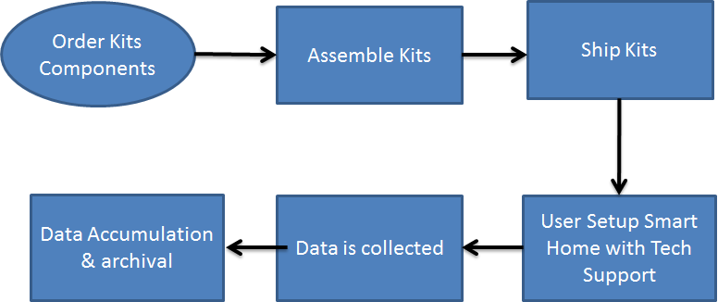

[B] Kit Creation:

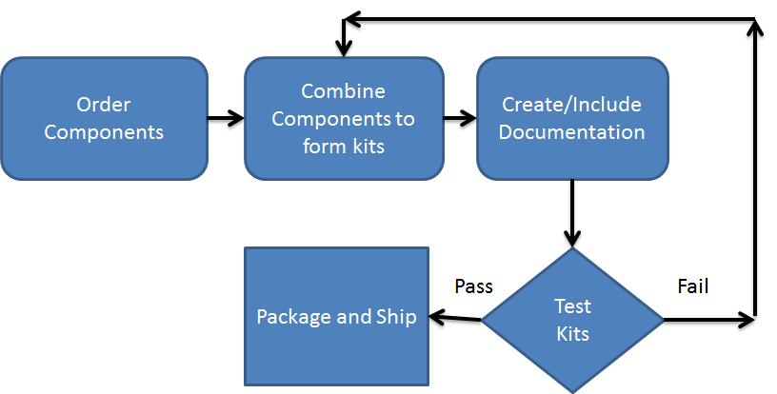

[C] Data Collection: (ASSUMING USER DOES NOT HAVE INTERNET AT HOME)

Offline Model:

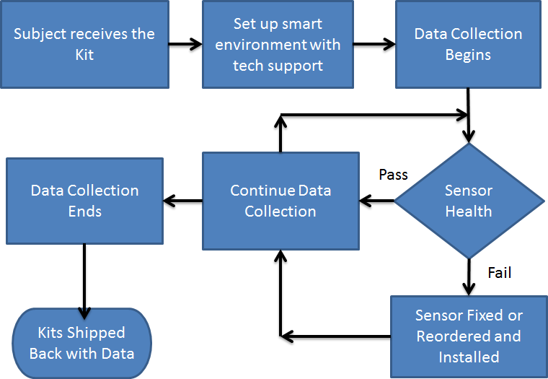

Finances

|  |  |  |
| --- | --- | --- |
| Description | Solution A Cost | Solution B Cost |
| Initial Costs (Set up/Recruitment/Others) | $5,000 | $5,000 |
| Kit Costs | $500,000 | $1,000,000 |
| Human Resources/Head Count/Team Costs @ per Year | $150,000 | $150,000 |
| Infrastructure Costs | $100,000 | $100,000 |
| Tech Support Setup/Costs | $50,000 | $50,000 |
| Maintenance Costs | $60,000 | $150,000 |
| Shipping + Miscellaneous Costs | $50,000 | $50,000 |
| (Note: These are approximates only) | $915,000 | $1,505,000 |

Timeline

|  |  |  |  |  |
| --- | --- | --- | --- | --- |
| # | Phases/ Task | Estimated Time | Milestone | People Involved |
| 0 | Identify and Hire Team | 3 Months | Milestone 0 | Stake Holder/Project Owners |
|  |  |  |  |  |
| 1 | Human Subject Identification | 6 months |  | Program Coordinator/ Marketing Manager |
|  | Human Subject Identification |  |  |  |
|  | Survey and Interview |  |  |  |
|  | Finalize candidates or participants | |  |  |
|  |  |  |  |  |
| 2 | Kit Assembly & Shipping | 3 months | Milestone 1 | Program Coordinator / Administrator / Marketing Manager |
|  | Order components |  |  |  |
|  | Assemble Kits |  |  |  |
|  | Test Kits |  |  |  |
|  | Ship Kits to participants |  |  |  |
|  |  |  |  |  |
| 3 | Data Collection Phase | 3 years | Mile Stone 2 | Program Coordinator / Administrator / Tech Support |
|  | Kits installed in homes | 6 months |  |  |
|  | Data collection | 2 years |  |  |
|  | Issues/Fixes/Support |  |  |  |
|  |  |  |  |  |
|  |  |  |  |  |
| 4 | Data Collection Completion | 6 months | Milestone 3 | Program Coordinator / Administrator / Tech Support |
|  | Data Archived |  |  |  |
|  | Kits Received back |  |  |  |
|  | Subjects/Participants incentivized | |  |  |
|  |  |  |  |  |

Issues/Risks

|  |  |  |
| --- | --- | --- |
| Risk Description | Risk rate (1-5)  5 – Max | Mitigation |
| Kits mainataince issues & replacements | 3 | Mainataince plan |
| Damaged kits returned | 4 | Recycle and resupply |
| Pilot study discontinued | 3 | Better user/subject selection |
| Data collection errors | 3 | Have a process to reach the subject and resolve the error.  Data Cleaning Plan in place. |
|  |  |  |

VNext

|  |  |
| --- | --- |
| Name | Description |
| Improve Workflow | Provide more detailing into workflow |
| Optimize roles | Optimize and create improved roles with more detailed responsibility and down size of fuse roles. |
| Conduct market survey | Conduct a full blown market survey to have an improved market analysis. |

Version

|  |  |  |
| --- | --- | --- |
| Version | Date | Changes |
| 1.0.0.1 | 3/13/2011 | Document Created |
| 1.0.0.2 | 3/15/2011 | Timeline, People, Finances, Risks, |
| 1.0.0.3 | 3/30/2011 | VNext and minor edits |